Senior/Principal Wireless Modem Architect

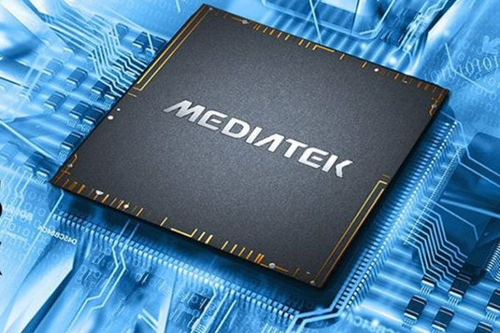

MediaTek

MediaTek is the world’s 4th largest global fabless semiconductor company, leading the market in chipset technology. We enable more than 1.5 billion consumer electronic products a year including Smart TVs, Voice Assistant Devices (VAD), Android tablets, feature phones, Optical and Blu-ray DVD players, and we’re number two globally in mobile phones.

MediaTek is also one of the top four companies globally to advance 5G development. Working together with component suppliers and worldwide cellular operators around RF technology, MediaTek is quickly bringing a complete, standards-based and optimized 5G solution to the market.

The Role
We have an excellent opportunity for a Senior/Principal Wireless Modem Architect to join our Modem Technology and Architecture team. The main goal of this position is to drive innovation and continuous improvements for the architecture of the cellular modems used in MediaTek’s latest and most advanced chipsets. As MediaTek’s next Senior/Principal Wireless Modem Architect, you will engage with experienced cross-disciplinary staff and will have the chance to work on the latest cellular communication standards, such as 5G NR Releases 16/17.

The Modem Technology Architecture team is currently involved in the architecture definition, design and validation of MediaTek’s 5G NR chipsets. In your role as Senior/Principal Modem Architect, you will be responsible for the architecture definition of state of the art cellular modems used in User Equipment (UE) devices. You will be comfortable working across HW/SW boundaries and will have experience exploring and quantifying the impact of different architecture decisions on performance, area and power consumption.

This senior role will be varied and will give you exposure to the modem architecture across the different software and hardware layers of our different cellular modem solutions. As MediaTek’s Senior/Principal Wireless Modem Architect, you will have opportunities to directly interact with hardware, DSP, software and standards engineers, both locally and across MediaTek’s global R&D sites.

About You
- You’ll have the ability to learn quickly, innovate and take responsibility for new and unfamiliar areas
- You’ll be a clear and concise communicator of complex ideas
- You’ll have a flexible working style and the ability to adapt
- You will thrive in a collaborative team environment, where colleagues are willing to listen to and learn from one another
- You’ll be able and willing to travel internationally (from time to time)
Required Skills & Experience
- Understanding of processor subsystems, memory and bus architectures
- Familiarity with cellular protocols, ideally including 3GPP NR
- Experience defining system architectures and exploring technical feasibility trade-offs
- Experience with specification, design and implementation of real time embedded SW in C/C++
- Experience in SW design for multi-threading processors

Desirable Skills & Experience
- Modelling, using C/C++ for example, of sub-systems within cellular modems

Qualifications
- Degree in Computer Science (or equivalent)

Location
This position is located in Cambourne (near Cambridge), UK and will form part of a multi-skilled, multi-site, international development team.

MediaTek and You
MediaTek look for people with a great passion and work ethic, who have a broad set of technical skills and are ready to master new technologies and tackle some of industry’s greatest challenges to positively impact billions of future users. From 4G and 5G smartphones, to tablets and digital television, MediaTek employees are changing the industry one innovative product after another.

We pride ourselves on having an accomplished and successful global collaborative team culture and a competitive compensation and benefits package. We know that every employee makes important contributions, and that every employee is integral to our success.

